**Vor Experiment Guide**

Andriy Khavro

73886

andreyucraniano@hotmail.com

David Honório

84947

dmfhonorio@gmail.com

Fábio Almeida

70227

fabio.vieira.almeida@tecnico.ulisboa.pt

1. **Introduction**

In a robot emergent world, every day we are confronted with new technologies that change our way of living. Soon robots will make part of our daily activities, be it cooking, working or even engaging in social activities. In order to understand how people react to this changes in our daily lives, and in order to improve our interaction with robots it’s important to know how people regard robots in daily situations.

In this experiment we purpose ourselves to study how the trust levels of a person towards a robot change after being confronted with a daily situation, lies.

1. **Research Question and Hypothesis**

**Research Question:** How does people’s trust level on a robot varies when confronted with a situation that the robot lies versus a situation where the robot tells the truth?

**H1:** The trust level will rise when the robot tells the truth.

**H2:** The trust level will diminish when the robot lies.

**H3:** The final trust level on the robot will be higher when the robot tells the truth compared to when it lies.

1. **The Experiment**

In order to understand how trust levels vary in confrontation with a theft situation, we’ve devised an experiment where the two participants engage in a simple task of cooperative cross-words solving were the robot (Vor) acts as a mediator. One of the participants will in fact be an insider or confederate, this way we can create a situation where the participant is confronted with theft (committed by the confederate) and the robot, which is aware of the theft, can lie.

Our target subjects will be both male and female adults comprised between the ages of 18 and 50. Due to the nature of the task (cross-words) the experiment will be conducted in Portuguese.

The task will have a duration of close to 15 minutes and the participants will have to answer to three questionnaires: two Trust Questionnaires (one before the experiment and another one after it) and a Godspeed Questionnaire. The total duration of the experiment will of 30-45 minutes.

All of the participants will have to sign a consent form and will be given a cinema ticket as a reward for helping with the experiment.

* 1. **The Flow**

The Participant will arrive and a Researcher will take him/her to perform the Trust Questionnaire. After the Trust Questionnaire the researcher introduces the Confederate (which will play the part of a simple participant) to the Participant. It is important that the Participant doesn’t know the Confederate and doesn’t suspect he is a part of the experiment.

The Researcher will then accompany both to the room where the experiment will occur. The robot will be in an asleep state and the screen will be asking for both participants names. After the researcher helps them input their names he’ll activate Vor and ask if they can start to Vor. Vor will greet everybody in the room and ask for the participants to hit the play button whenever they are ready. The Researcher will then leave the room forgetting his watch (the watch will already be in place before the three enter the room) besides the screen where Vor can see it.

Once the Researcher is out of the room, and before the game starts, the Confederate takes the watch and puts it in his pocket. Vor will immediately ask if the watch is his and the Confederate will give and affirmative answer. Conformed with the response, Vor will ask the participants to hit the play button commencing the cross-words puzzle.

After seven minutes of play Vor will end the activity saying that they are out of time to solve the problem and the Researcher will then appear and ask for the watch directly to Vor.

At this point Vor will have the chance to lie or tell the truth to the Researcher. It will either say that he doesn’t know of the watch or that the Confederate has it. Either way Vor will excuse himself returning to the sleep state.

The Confederate will then assume that he has indeed the watch saying that he was only keeping it to give it back later. The Researcher will then take the Participant to answer the final questionnaire (the Confederate will be escorted by a second Researcher).

* 1. **The Setup**

The experiment will take place in the GAIPS demo’s room. We will use a touch screen where the participants will engage in the activity. The robot will be in front of the participants and the screen will be between the participants and the robot. The participants will perform the task side by side (the confederate will always stand on the left of the participant), check Figures 1 and 2 for better understanding. All of the experiment will be recorded by cameras.

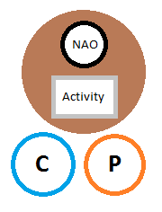

Figure 1 – The experiment setup. C stands for Confederate and P for Participant.

Adicionar foto do setup

* 1. **The Robot**

In this experiment we will use a NAO robot torso as seen in Figure 3. We will conduct the experiment with a WOZ setup. The NAO will be sufficiently autonomous to respond to stimulus from the activity and will be able to track people faces using the Kinect. Despite that, the robot will be controlled in a WOZ fashion, which means we’ll have a researcher that will control the robot “behind the curtains”. Has part of the WOZ Interface we’ll have a camera and microphones transmitting both image and sounds so that we can best accompany the experiment.

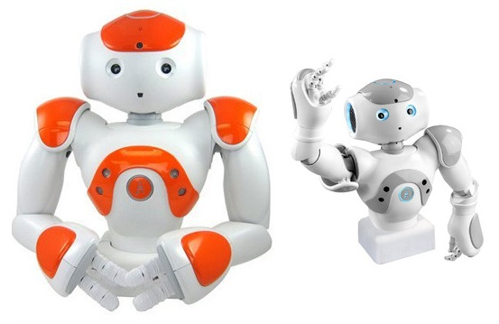

Figure 3 – NAO robot torso

1. **Architecture**

As said before the robot will be controlled mostly in a WOZ fashion. It is, however necessary to explore the architecture of the system we have developed.

We have built our system with the model of the SERA ecosystem using some of its tools, namely Thalamus and Skene. Based on the SERA model we developed two models of software: VorWOZ and VorApplication, which are described in sections 4.3 and 4.4 respectively. As the names imply, the first is our point of control of the robot and the second is the game in which the participants will engage. An overview of the architecture can be seen in Figure $.

Adicionar figura da arquitectura

* 1. **Thalamus**

Thalamus acts as a communication bridge between modules. It provides facilities to exchange messages and modules can either subscribe to or publish messages. In these way, whenever the AI module decides to speak all the modules that have subscribed to those kind of messages will be notified. It can, for example, be the module of text-to-speech and the module that controls the robot movement that act accordingly, giving the robot the according movement to the speech act.

* 1. **Skene**

Skene is a semi-autonomous behavior planner that translates high-level intentions originated at the decision-making level into a schedule of atomic behavior actions. We can ask the robot to speak a certain type of sentence (e. g. greeting somebody) and Skene will select from a library of sentences and animations.

* 1. **VorWOZ**

We’ve devised an interface to facilitate the control of the robot, represented in Figure $. This is where all of the autonomous control of the robot will happen and can, later, be replaced by a real decision making AI.

Most of the decision making on controlling the robot will be made upon viewing and hearing the participants through the use of an utterance library also constructed by us (check section 4.5), but we’ll also have feedback whether the participants are clicking in the application so that we can respond accordingly.

Adicionar figura do VorWOZ

The application we’ve developed won’t be the only part of the WOZ Interface. We’ll also need to see and hear the participants. For that we’ll use Skype, this will enable us to watch the participants in order to make Vor more believable.

* 1. **VorApplication**

The application where the participants will play the cross-words game mediated by Vor. This will be a simple HTML page served by a custom HTTP server written in C# so that we can connect the application to Thalamus. This way we can know what is happening in the game and can make the robot take the accordingly actions.

* 1. **Utterance Library**

This isn’t so much a component of our system but more of a resource. In order to use Skene we need to have an utterance library of what the robot can say, annotated with gestures, gazing, pauses and others. This library will be available on VorWOZ so that we can quickly order the robot to say whatever we want him to say. This utterance library will be provided as an attachment to this guide.

The use of such library will helps to make the robot more believable since we can define several utterances to soy the same thing. It will enable the robot to seem more natural in its communication process with the participants.